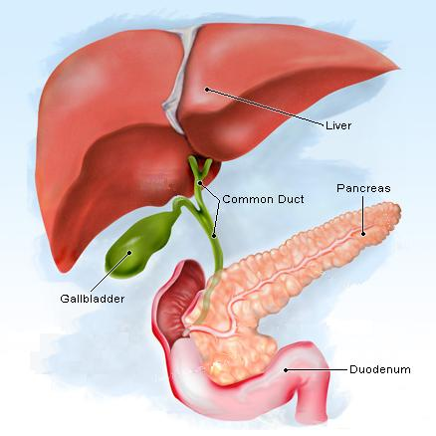
Liver Surgery
Liver surgery is undertaken for removal of tumours – from the liver and/or bile ducts. Most commonly this surgery is performed for removal of secondary cancers from the bowel that spread (metastasise) to the liver. A smaller percentage of patients have primary liver cancer-HCC, (hepatocellular carcinoma), (cholangiocarcinoma) etc. If the bile duct is reconstructed, a bile duct to bowel join anastomosis will be performed. The surgery is mainly done through a large incision shown above but sometimes keyhole surgery can be done. Dr Ahmed will advise on this.
What to expect :
Dr. Ahmed will explain to you why you are having this surgery. This operation does take a number of hours to be performed. A liver protocol sheet will be given to you.

You will be admitted to the Intensive care unit after your operation; and Dr Ahmed /team member will discuss the operation findings with your family member (or next of kin). Usually your pain will be well controlled with IV/oral pain killers; and you will usually be started on a fluid diet- the 1st or 2nd day after the operation.
You need to be aware of the reasons for this type of surgery and the risks involved:

Death(mortality) from surgery – 1-2 %
  - Bleeding – massive bleeding that can occur during or after the operation
    - This may require re-operation to stop the bleeding.
  - Liver failure – where the remaining liver is not sufficient to meet the body’s needs. This can develop rapidly. This risk depends on the current state of the liver and how much liver tissue is removed. It can also occur if the portal vein/hepatic artery becomes clotted/thrombosed. You will become jaundiced, yellow and may become confused and go into a coma.
Bile leak – green/yellow liquid which is made from the liver and can then leak from the cut surface of the liver. This, if present will be seen in the drain bag. (Dr Ahmed will let you know this)
  - Infection/collections
    - May require further drainage tubes to be placed-higher risk if the bile duct is reconstructed (bile duct to bowel join)-leaks can occur
    - ERCP – a specialised endoscopic procedure to drain the bile duct internally with a stent.
  - Community nursing to manage drains
Chest infections – its important you perform the chest physio exercises; and blow regularly the triflow machine (3 balls or single disc) given to you
Ileus (where the bowel stops working ; and your abdomen becomes distended like a “balloon”)
Chronic pain – ongoing constant pain at the incision site/chest wall.
Long stay in ICU/Hospital – any complications/setbacks that occur will delay your progress. Dr Ahmed will keep you informed and you/your family can ring him at any time to discuss. (mobile -0414465617)

After the operation
-It is important you perform the chest physio exercises/and mobilise as much as possible
-Your length of stay is on average 1 week; but this can lengthen if any complications/setbacks occur-You will be discharged with stockings (TEDS) and subcutaneous injections – Clexane ; to keep the blood slightly thinned to prevent blood clots ( this is for 4 weeks)
- You will need to slowly wean yourself from pain killers and take Lactulose to keep your bowels moving.

You will see Dr Ahmed in 3-4 weeks following the surgery; and complete physical and mental recovery usually takes 1-2 months to occur.

