Dr. SULMAN AHMED MBBS (syd.) MS (syd.) FRACS 40 Colless Street
Hepatobiliary & General Surgery Penrith NSW 2750
Gastroscopy • Colonoscopy • Laparoscopic Hernia • ERCP Ph (02) 4721 7533
Nepean Public and Nepean Private Hospitals Fax (02) 47217759
Provider No: 222836UH. ABN: 15610929114 reception@nepeansurgery.com.au

VENTRAL/UMBILICAL HERNIA
Hernias are common and the operation is usually done through an open incision. Some operations can be done laparoscopically.
The aim is to find the hole in the muscle; close the hole and reinforce the hole with mesh.
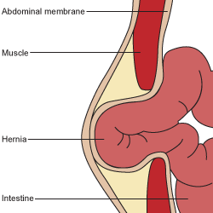
- Usually overnight stay in hospital
- Watch bowel habit – avoid constipation- may require bowel softeners eg. Lactulose
- Leave dressings on for 1 week – they are waterproof
- NO driving for 1 week
- NO heavy lifting for 4-6 weeks (<5kg)
- See DR AHMED in 3 weeks
RISKS:
- Chronic pain (nerve irritation)
- Hernia recurrence (hernia can come back)
- Strangulation if left untreated
- Bleeding, fluid collections (seroma) can cause vague hard swelling weeks after surgery and may require further treatment (operation).
- Infection – wound +/- mesh (may require further operation if the mesh is infected this may need to be removed)
- Needing an open procedure if initially done by keyhole approach
***Any concerns about the operation please contact the rooms and we will organise an urgent review.

