Dr. SULMAN AHMED MBBS (syd.) MS (syd.) FRACS 40 Colless Street
Hepatobiliary & General Surgery Penrith NSW 2750
Gastroscopy • Colonoscopy • Laparoscopic Hernia • ERCP Ph (02) 4721 7533
Nepean Public and Nepean Private Hospitals Fax (02) 47217759
Provider No: 222836UH. ABN: 15610929114 reception@nepeansurgery.com.au

GALLBLADDER SURGERY-Common operation to remove the gallbladder containing stones but it can be done for other reasons.
The operation also involves an x-ray test to assess the bile duct for stones. If required you may need another procedure, (ERCP).
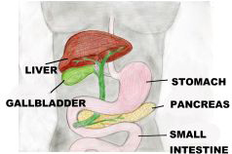
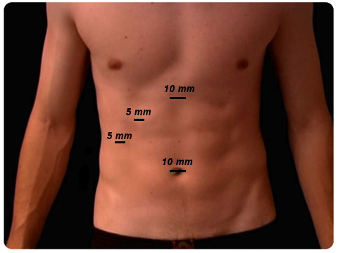
After the surgery: Risks:
- Leave dressings for one week and then remove, they will be waterproof 1. Conversion to open surgery 1%-if difficult-due to adhesions or abnormal anatomy
- No driving for one week 2. Bile duct injury 1/500 – may require further procedures/operations
- No heavy lifting for two weeks 3. Bile leak (may require re-operation in the form of ERCP)
- If you have open surgery the recovery time will be longer 4. Need for ERCP (usually if stones in common bile duct), or minor bile leak
- See Dr Ahmed in rooms for review 3 weeks after surgery 5. There may be a need to place a stent (plastic tube) to help with the ERCP
- Any concerns contact the rooms during business hours. (Subsequent procedure) Dr Ahmed will explain this after the operation.
- Please be on a light diet for three weeks (no rich, greasy or heavy food) 6. Irritable bowel syndrome – symptoms may increase if present before surgery
- nausea, vomiting, abdominal pain, bloating, diarrhoea.
7. Normal to have loose bowel motions which will settle down (weeks).
8. Injury to other organs/bowel.

