Dr. SULMAN AHMED MBBS (syd.) MS (syd.) FRACS 40 Colless Street,
Hepatobiliary & General Surgery Penrith NSW 2750
Gastroscopy • Colonoscopy • Laparoscopic Hernia • ERCP Ph (02) 4721 7533
Nepean Public and Nepean Private Hospitals Fax (02) 47217759
Provider No: 222836UH. ABN: 15610929114 reception@nepeansurgery.com.au

INGUINAL HERNIA SURGERY (laparoscopic/keyhole)-This is a common surgical procedure.
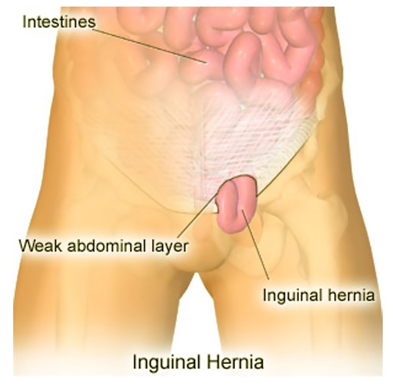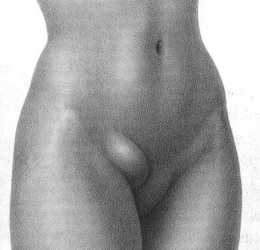

The aim is to find the hole (defect) in the muscle and bridge Risks:
the gap by placing mesh. Groin hernias can be inguinal or 1. Chronic pain (nerve irritation)-Burning sensation. A very rare problem but if
femoral depending on where the hole (defect) is located. ongoing a referral to a pain specialist may be required.
Inguinal hernias are divided into direct and indirect defects 2. Recurrence (hernia coming back)-Rates of 1-2% per 5yrs. Can occur due to
(and patients can have both). mesh shrinkage
3. Bleeding or infection of wound/mesh
4. Converting to open procedure if not able to do procedure laparoscopically safely
5. Strangulation (if left untreated)
6. Injury to testicular vessel (extremely rare) where the testicle may shrink or die.

