Dr. SULMAN AHMED MBBS (syd.) MS (syd.) FRACS 40 Colless Street
Hepatobiliary & General Surgery Penrith NSW 2750
Gastroscopy • Colonoscopy • Laparoscopic Hernia • ERCP Ph (02) 4721 7533
Nepean Public and Nepean Private Hospitals
Provider No: 222836UH. ABN: 15610929114 reception@nepeansurgery.com.au

ERCP - CHOLANGIO-PANCREATOGRAPHY-
This is an endoscopic examination where a tube is placed through the mouth. You will have a general anaesthetic and will be lying down on your abdomen (on an X-ray table). You will be given antibiotics (let us know if you have any allergies). This is usually a day procedure but if complications occur you may need to stay in hospital for longer.
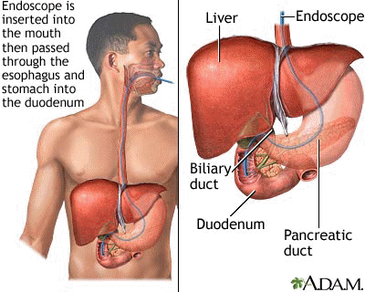
RISKS:
  - Bleeding-ensure you have stopped Aspirin, Plavix, Warfarin or other anti-platelet/anticoagulant for seven
Days prior to procedure
  - The need for another procedure-eg. Large stones may require further procedures to break the stone up.
  - Perforation (hole in bowel) rare which may require an operation

  - Pancreatitis- 10%; severe upper abdominal pain following procedure and you may need to stay in hospital for a few days/1 week until this settles. Severe pancreatitis is rare but if it occurs you may need a feeding tube and stay in hospital for a few weeks.
  - To decrease pain and the risk of pancreatitis Dr Ahmed will place an Indocid suppository if appropriate.

n

