Dr. SULMAN AHMED MBBS (syd.) MS (syd.) FRACS 40 Colless Street
Hepatobiliary & General Surgery Penrith NSW 2750
Gastroscopy • Colonoscopy • Laparoscopic Hernia • ERCP Ph (02) 4721 7533
Nepean Public and Nepean Private Hospitals
Provider No: 222836UH. ABN: 15610929114 reception@nepeansurgery.com.au

ENDOSCOPY- usually day procedure
Colonoscopy Gastroscopy
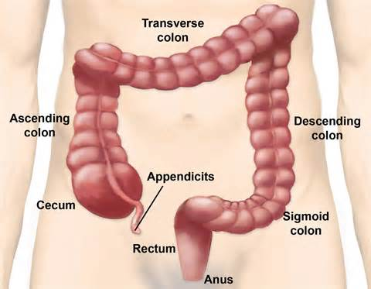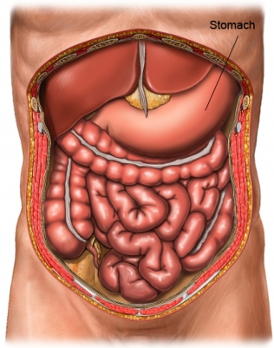
Preparation:
- 7 days prior to the procedure you are required to stop Aspirin, Fish Oil, Glucosamine and all other natural blood thinning agents.
- 1-2 days before: Bowel prep eg. Picoprep, Picolax or Moviprep -instructions overleaf
- Make sure your bowel motions are becoming clear - you may require extra prep!
- Routine biopsies may be taken and also a check for Helicobacter Pylori is done.
- If haemorrhoids are suspected Dr Ahmed will usually place rubber bands.
- See Dr Ahmed in rooms 3weeks after procedure/s to discuss results.
RISKS:
- Incomplete exam – This may occur if I cannot pass the scope through to the end of the lower bowel - X-ray test (Barium enema or CT colonography)
- Perforation (1/1000) – This is a hole in the bowel. It can be caused by the procedure, from removing polyps or entering a diverticulum or going through tight bends- this may need surgery
- Bleeding (rare) usually from removing large polyp usually on the right side of the colon.

